Family Science Night
October 7, 2014
S6CS2. Students will use standard safety practices for all classroom laboratory and field investigations.
a. Follow correct procedures for use of scientific apparatus.
b. Demonstrate appropriate techniques in all laboratory situations.
c. Follow correct protocol for identifying and reporting safety problems and
violations.

Students & Family
Join us for an evening of
Science Activities and Fun

October 7, 2014
5:30 P.M. – 7:00 P.M.
Columbia Middle School

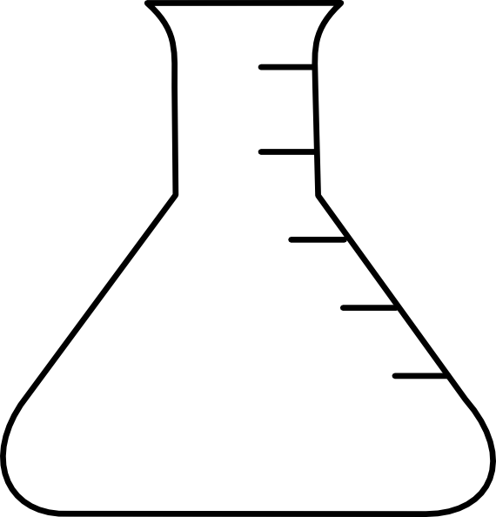
fun
for
some
Experiments
Kooky
Wacky
and
Explosive
Join Us

